**README FILE FOR GUI**

**Team Number: 4**

|  |  |  |
| --- | --- | --- |
| **USN** | **ROLL NO** | **NAME** |
| **01FE19BCS275** | **509** | Bhuavn M C |
| **01FE19BCS279** | **512** | Shreehari T Alagawadi |
| **01FE19BCS304** | **534** | Raghavendra A Hallyal |
| **01FE19BCS290** | **522** | Supriya Khemalapure |

**PREREQUISITES :**

1. **DB BROWSER(SQLITE) AND CREATE TABLES .**

[**https://download.sqlitebrowser.org/DB.Browser.for.SQLite-3.12.2-win64.msi**](https://download.sqlitebrowser.org/DB.Browser.for.SQLite-3.12.2-win64.msi)

1. **INSTALLED PYTHON**
2. **INSTALLED VSCODE EDITOR**
3. **SQLITE PACKAGES CONNECTING VISUAL STUDIO (MY CASE)**

[**https://www.sqlite.org/2021/sqlite-tools-win32-x86-3350500.zip**](https://www.sqlite.org/2021/sqlite-tools-win32-x86-3350500.zip)

1. **QT5 DESIGNER (FOR DESIGNING GUI )**

[**https://build-system.fman.io/qt-designer-download**](https://build-system.fman.io/qt-designer-download)

**STEPS TO BE FOLLOWED:**

**Step 1: Extract the given zip folder.**

**Step 2 : Open Visual Studio.**

**Step 3: Click on Open folder.**

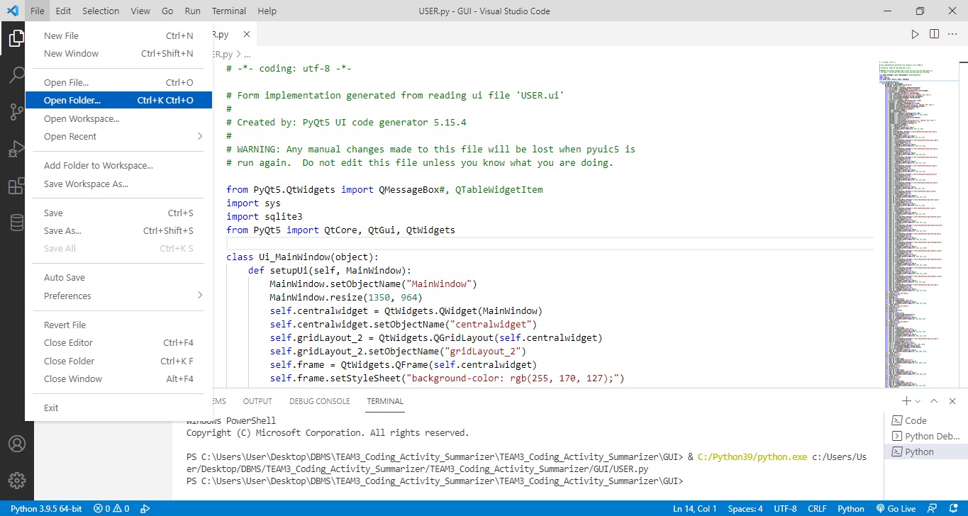

**Step 4: Select the GUI folder inside the folder that you got after extracting given zip file.**

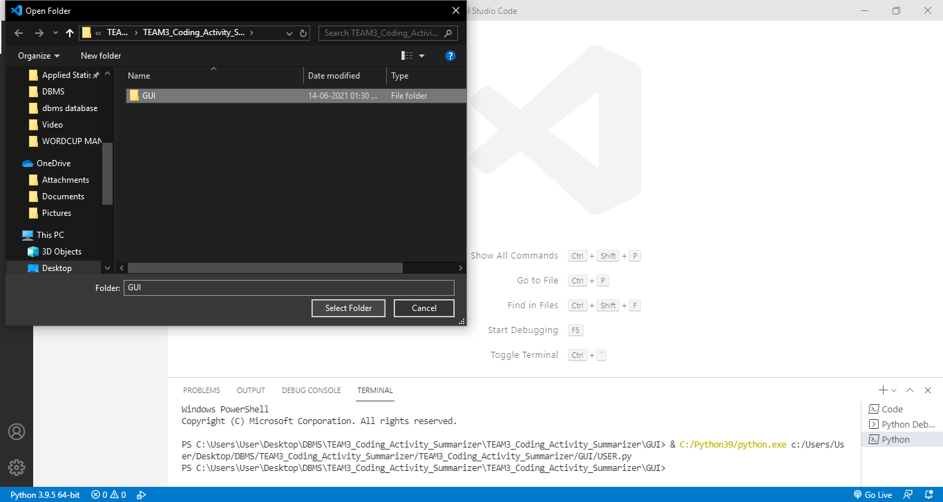

**Step 5: Search final2.py file and open it.**

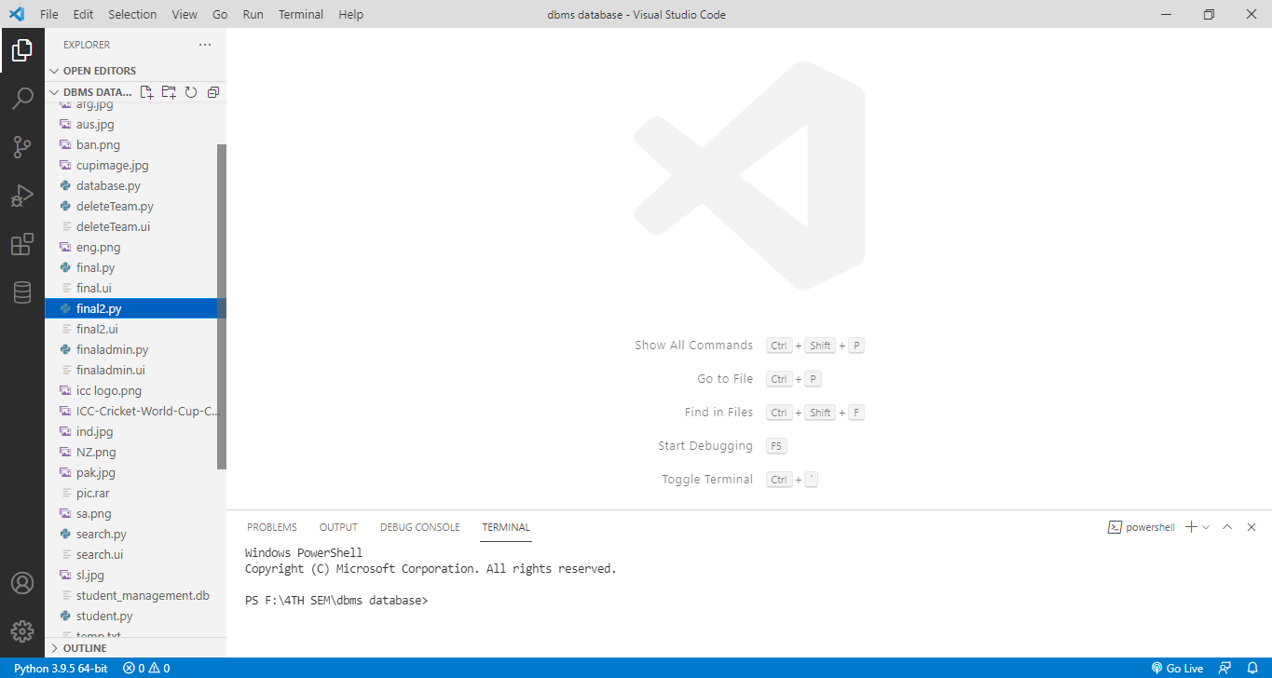

**Step 6: Run the code (as shown below).**

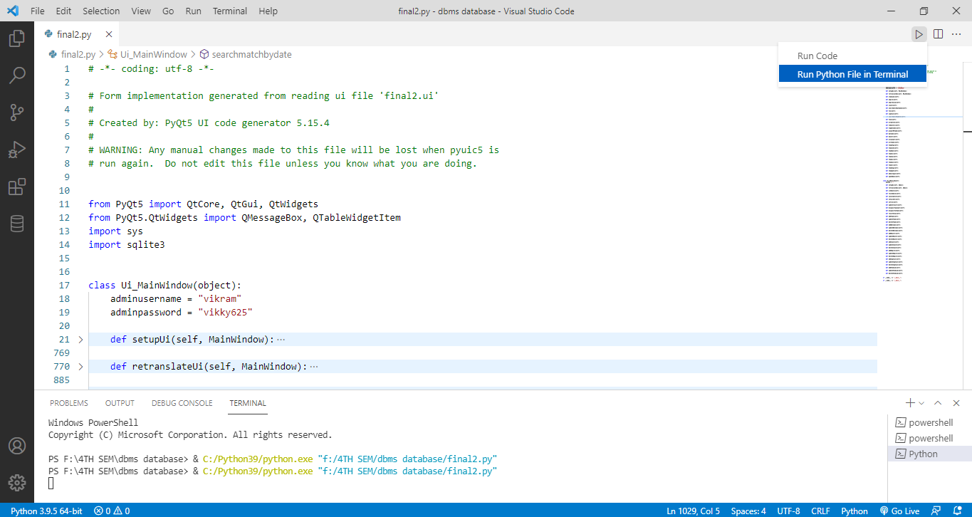

**Step 7 : The following window will open. Icons may or may not be displayed.**

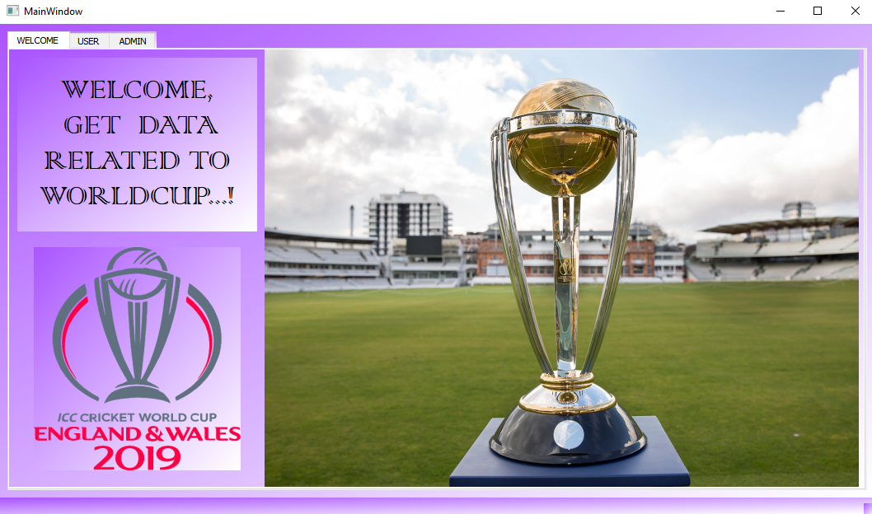

**1.USER (Get information about World cup teams, players, matches etc)**

**1.1 :** To get Teams information go to **Teams** tab

* If you are a normal user you can get all details about Worldcup in the USER tab.

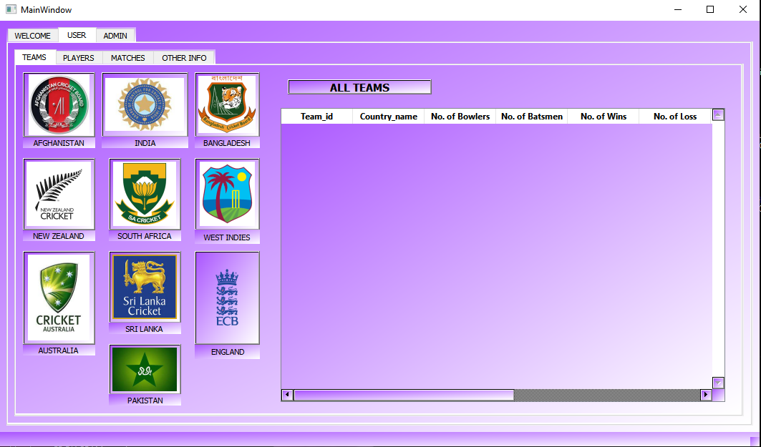

* You can click on each **team icon** to get that particular team details.

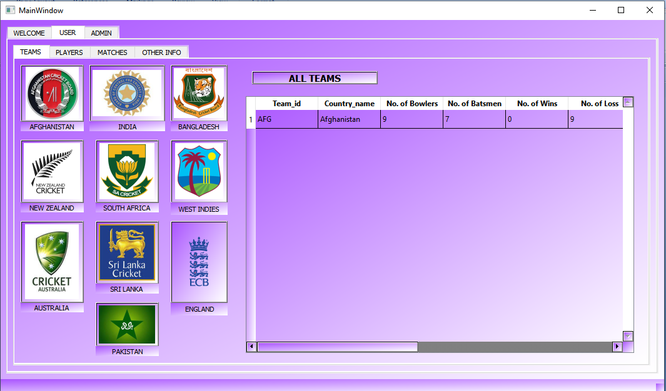

* You can click on **All teams to** get info of all teams.

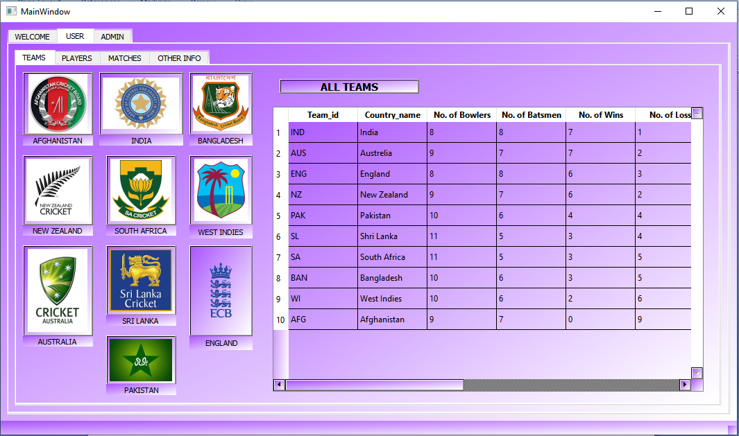

**1.2 : To get player info** open **Player** tab

* In player tab you can enter team Id and get all players by clicking **All players**,

**Batsmen** and **Bowlers** of a particular team.

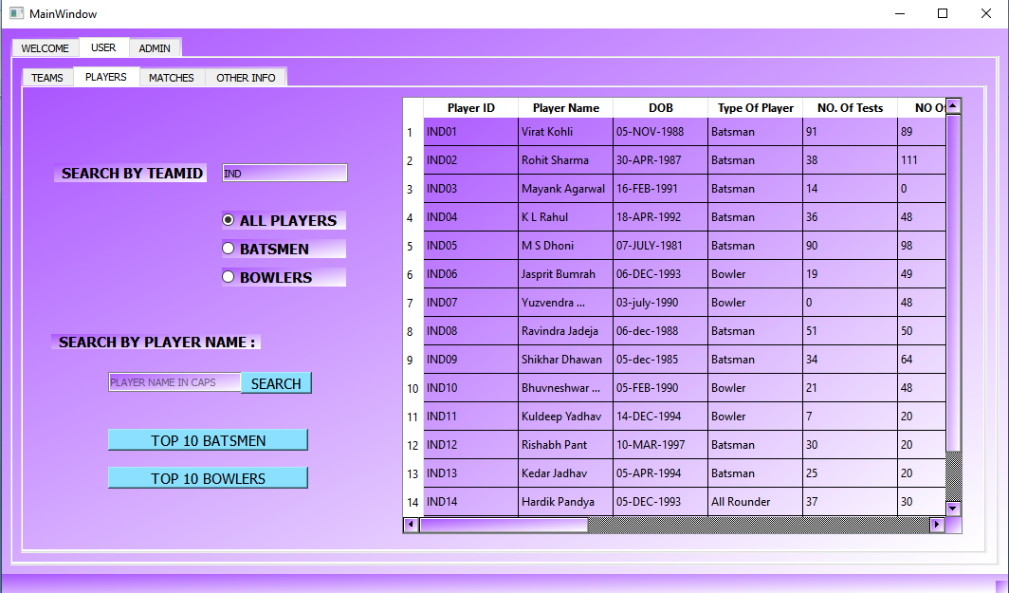

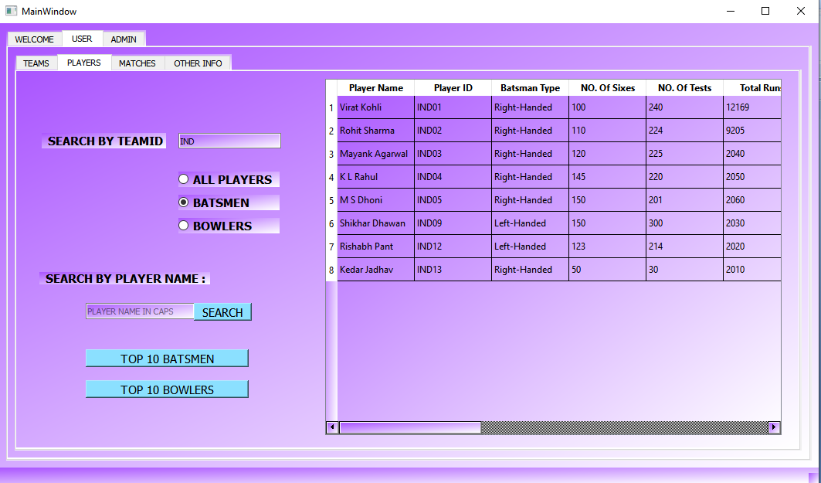

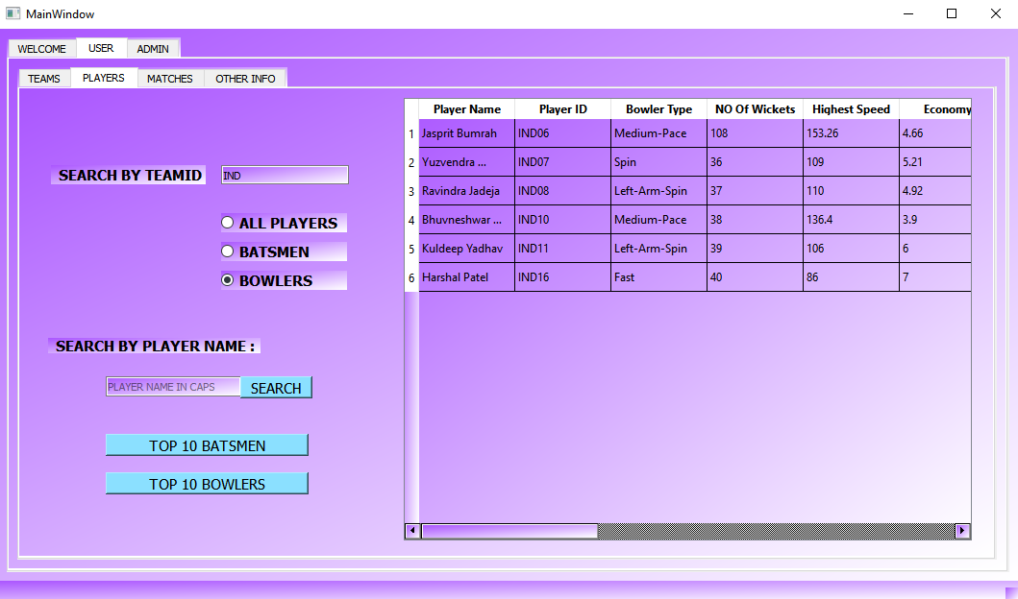

* Get details of your favourite player by searching his name .

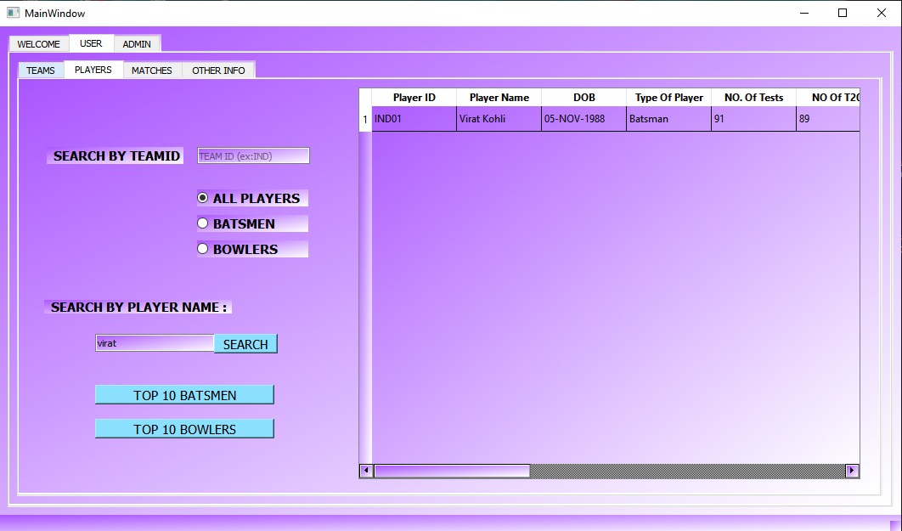

* Get **Top 10 batsmen** of the tournament by clicking top 10 batsmen button.

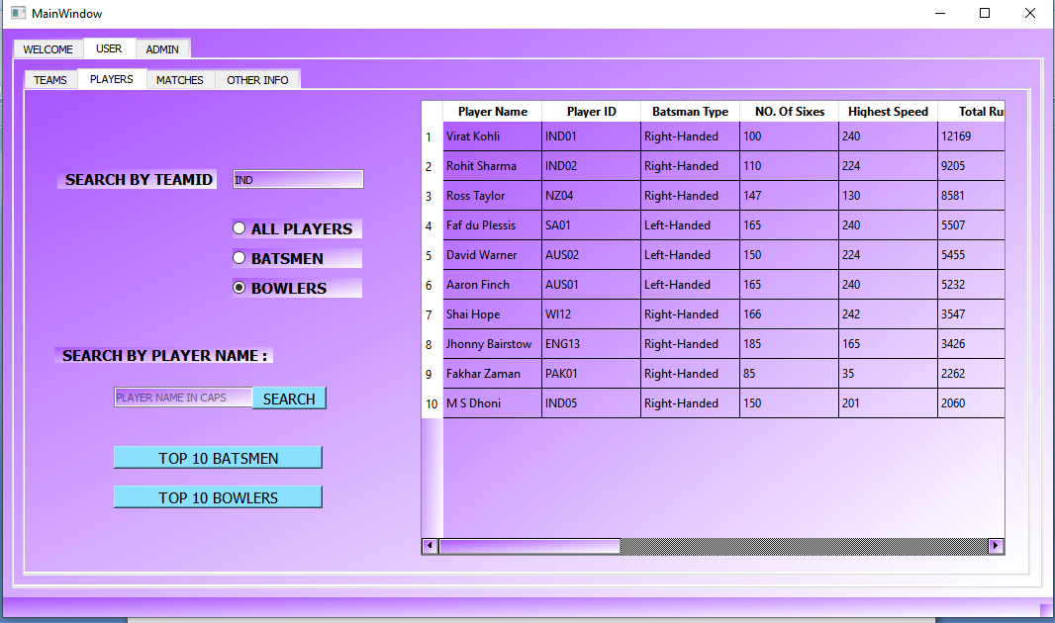

* **Top 10 bowlers** of the tournament by clicking top 10 batsmen button.

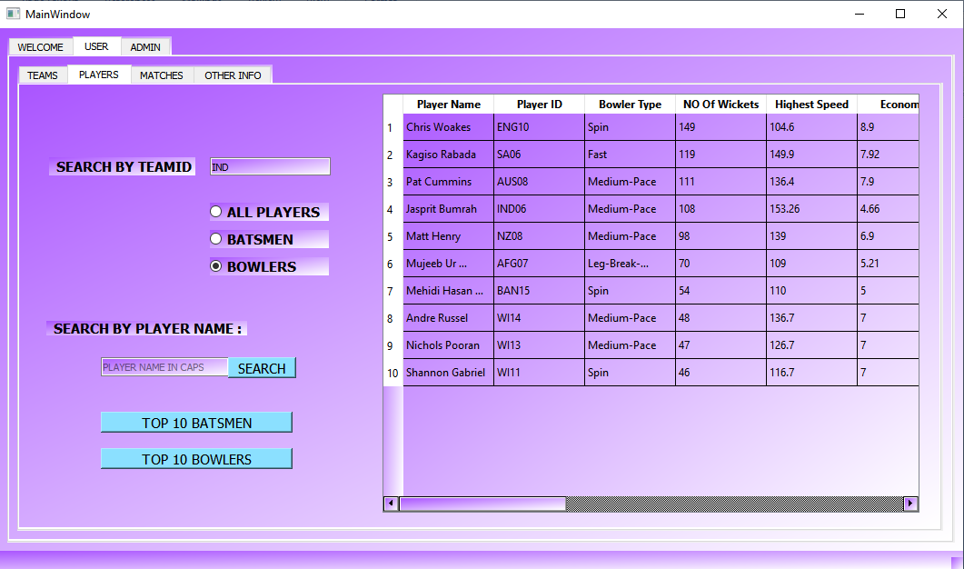

**1.3 : To get info about matches open Matches tab**

* Get info of all matches by clicking display all matches.

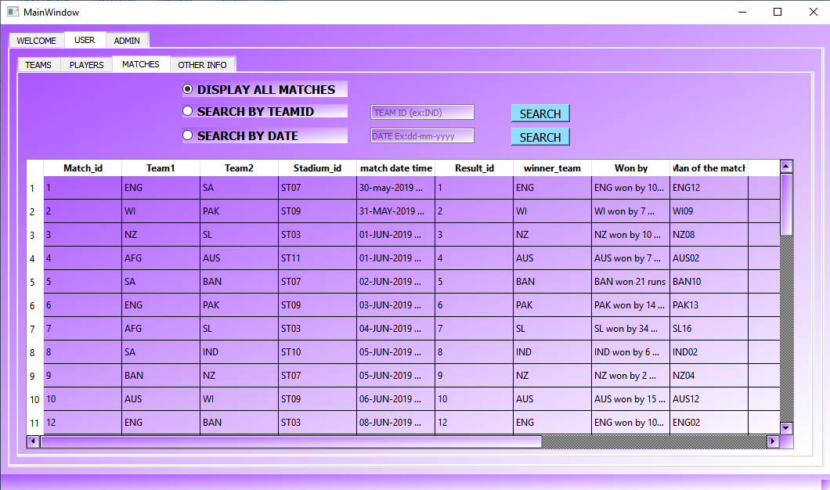

* Search your favorite team to check the information of matches and its result.

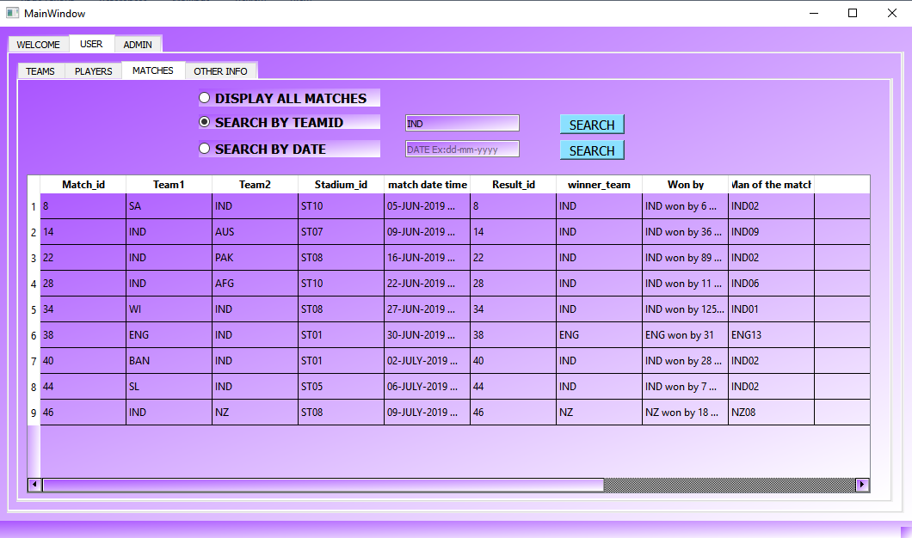

* Get match details of a specific date.

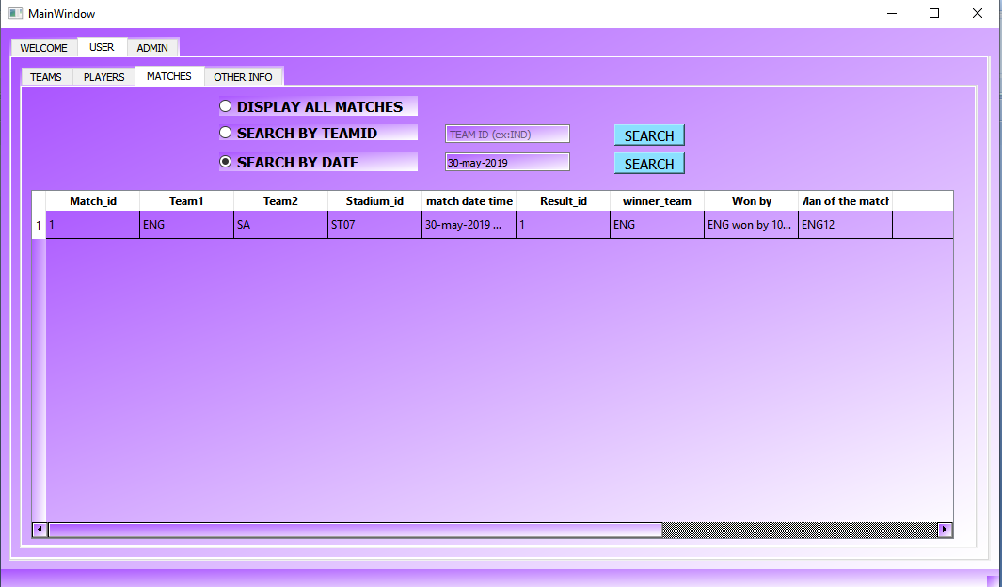

**1.4 : To get captain, stadiums, coaches, umpires info open Other Info tab**

* click **Display all captains**  to get info of captains of all teams.

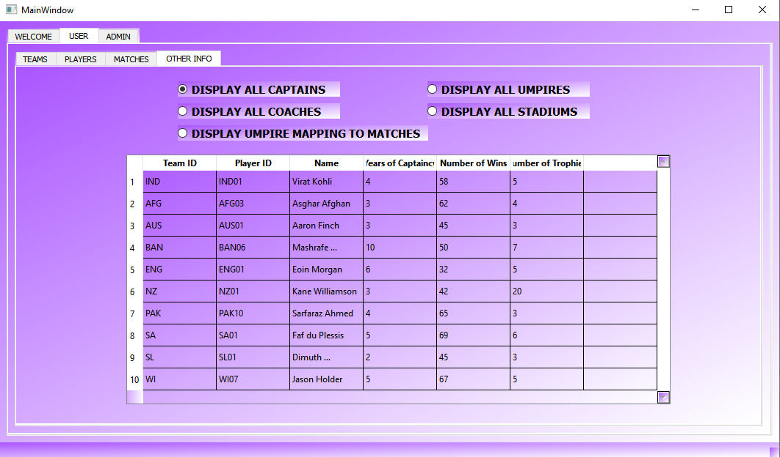

* Click **Display all coaches** to get all coaches info.

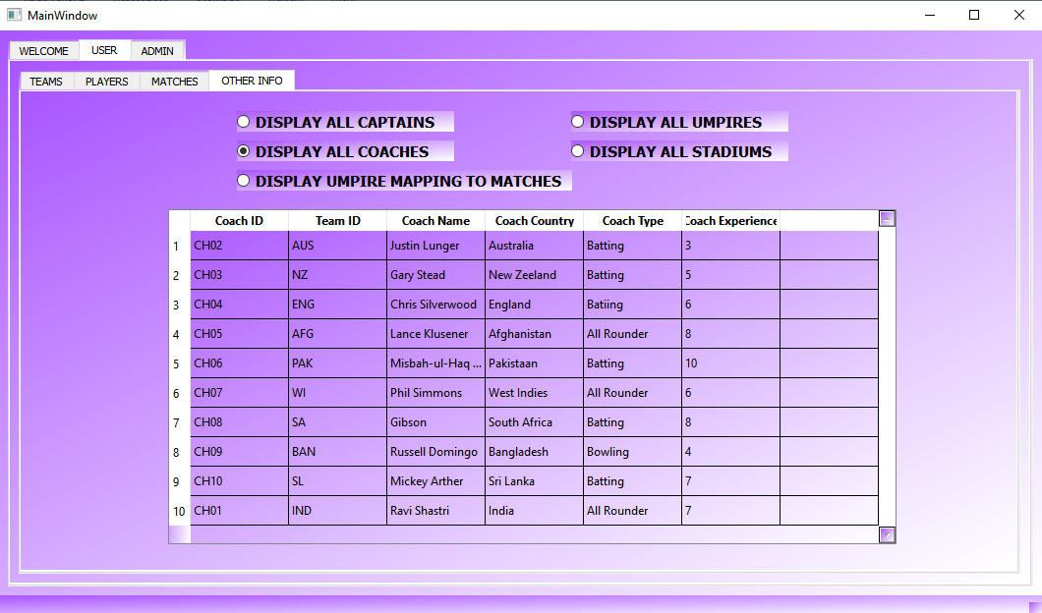

* Click **Display umpire mapping to matches** to get umpires allocated to all matches.

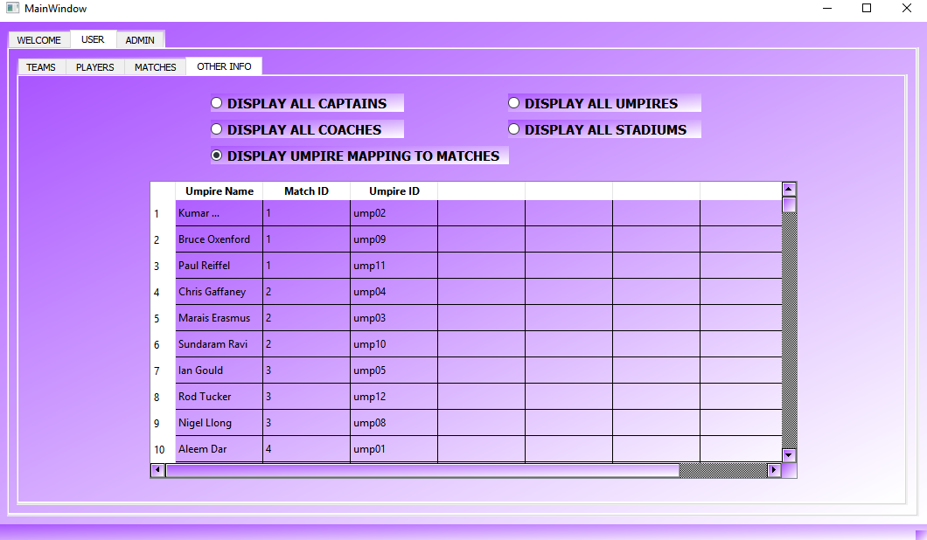

* Click **Display all umpires** to get all umpire’s info.

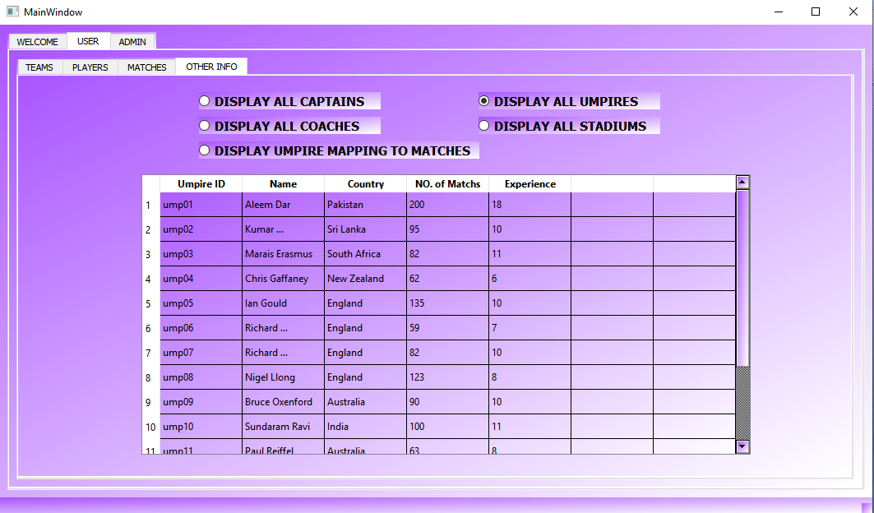

* Click **Display all Stadiums** to get all stadiums info where worldcup matches are going to occur.

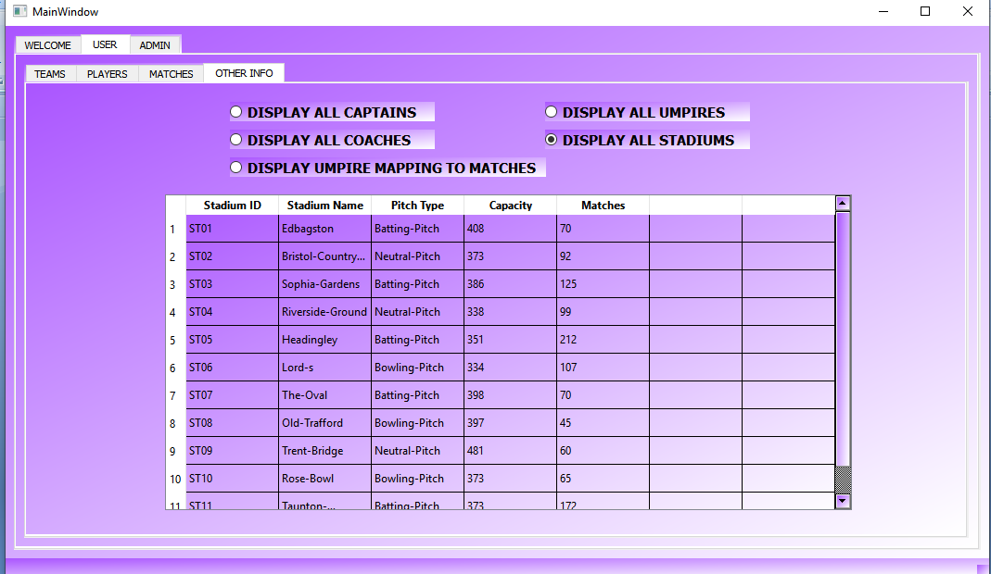

**2.ADMIN**

* If you are admin enter your **username(vikram)** and **password( vikky625 )** and click **Login.**
* Another window will open where all the admin activities can be done.

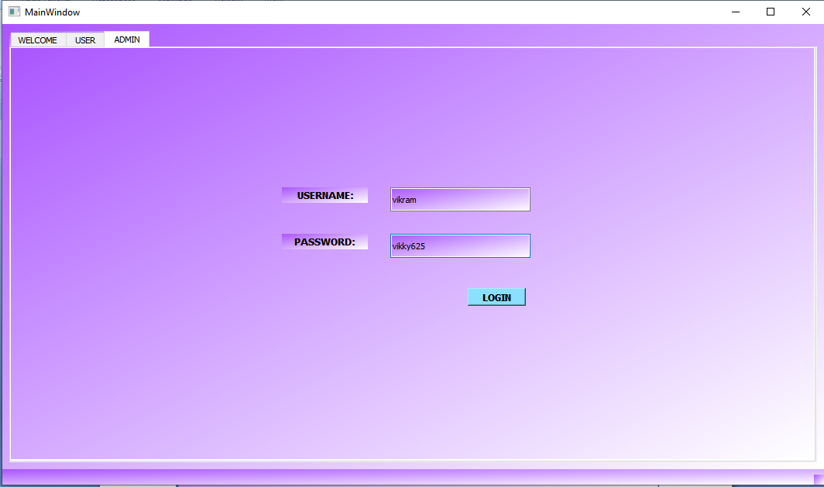

**2.1 : To schedule matches and update result go to SCHEDULE MATCHES tab**

* To schedule a match enter **Team ids** of both teams ,the date and time of match ,it’s venue(stadium) and 3 **umpires** who will umpire the matches
* Then click **schedule**. A confirmation message is displayed with match number

Click **ok**.

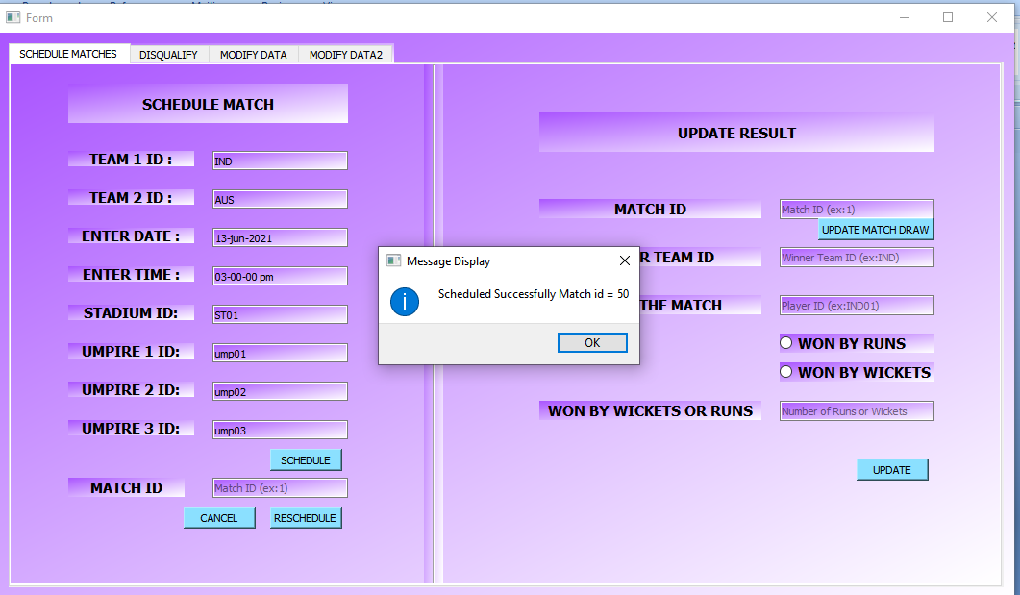

* To reschedule a match enter Match ID and date and time and click **reschedule**.

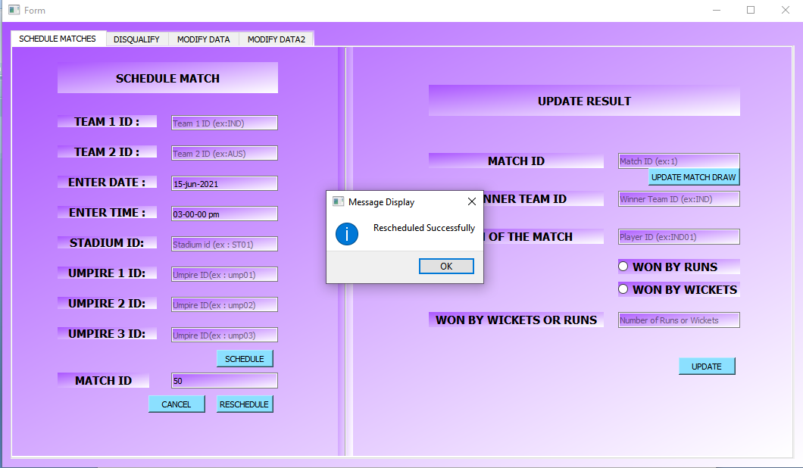

* To cancel the match enter Match ID and click **cancel**.

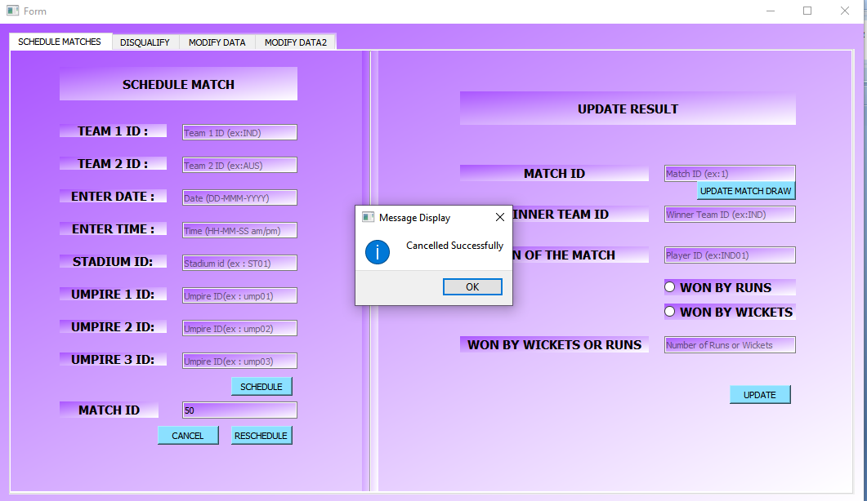

* To update the result of a match enter it’s match ID if it is draw click on **update match draw** button. Otherwise enter winner team ID . Select whether they won match by **wickets** or **runs** select respective button.
* Enter number of wickets or runs in **Won by wickets** or runs.
* Click **update**. The result will be updated.

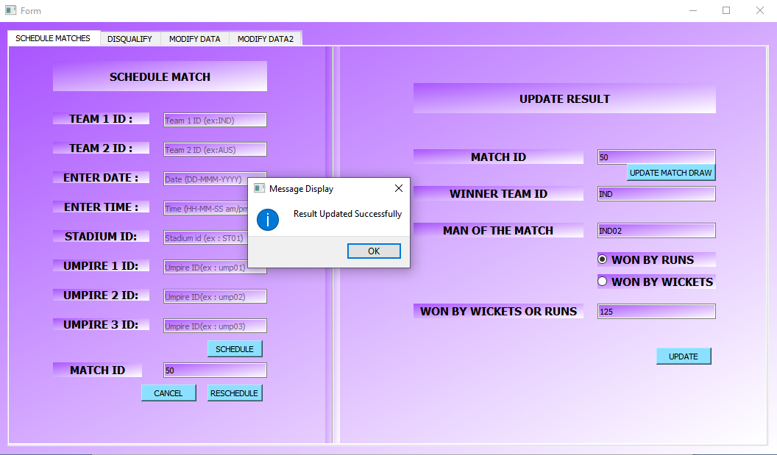

2.2 : To disqualify a player or a team go to Go to **DISQUALIFY** tab

* Enter Player ID and click **Go (**that player will be disqualified**)**.

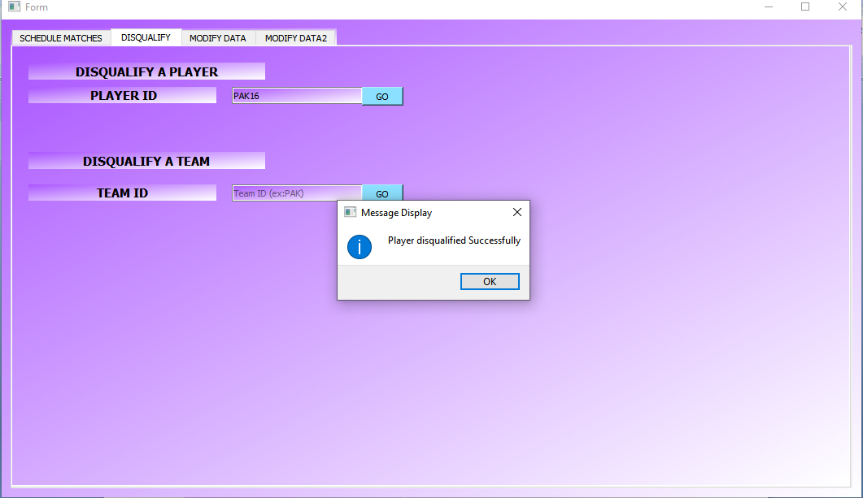

* Enter Team ID and click **Go** **(**that team will be disqualified**)**.

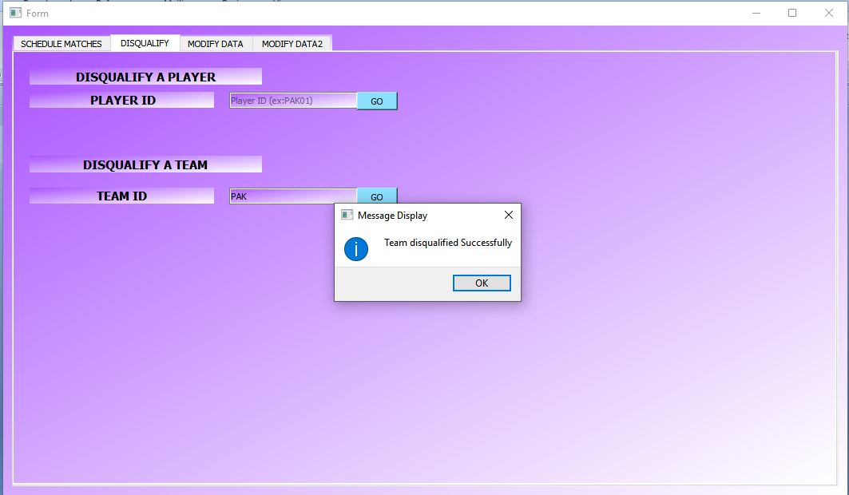

**2.3 : To add, update or delete teams or players go to MODIFYDATA1 tab**

* To add to, update or delete data from database.
* Enter the new values of new record to be added and click **insert**.
* A message box will be displayerd and your data will be saved.

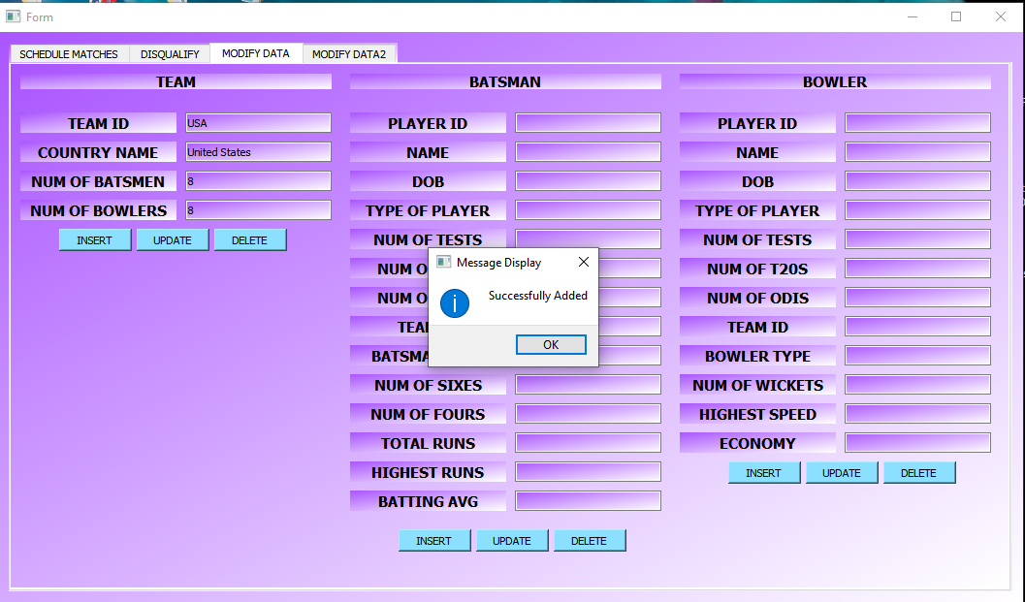

* You can also update any table data by entering updated values and click **update**.

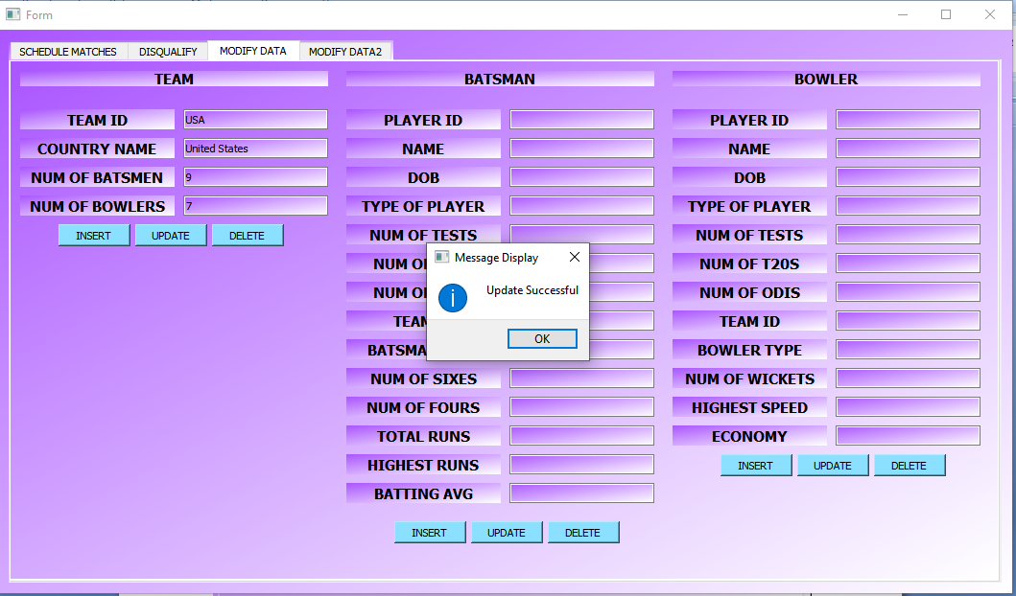

* To delete a team Enter a TeamID and click **delete**.
* A message box will be displayed and your data will be deleted.

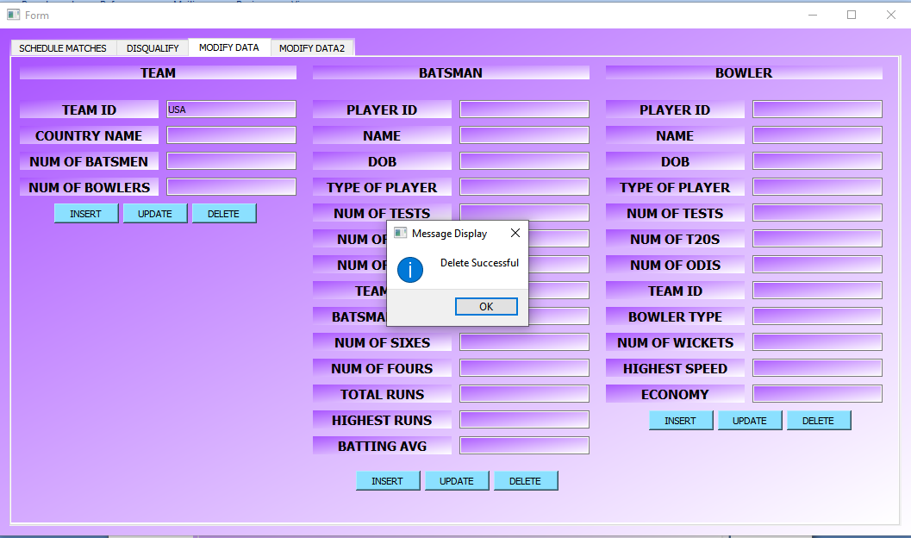

Like this **batsmen**, **bowlers** data can also be added modified or deleted.

**2.4 : To add, update or delete captains, coaches, umpire, stadium go to MODIFYDAT2 tab**

* Here captains, stadiums, coaches, umpire data can be added modified or deleted like same way you have done while adding, deleting, updating Team data in previous tab.